**W3 – Fall 2022 – Yalun Jiang**

**Problem:**

1. Impact force modelling between robot and environment
2. Contact force modelling for multi-contact scenario

**Solution:**

1. The contact force can be divided by two stages, impact and contact. The principles for modelling them are different since impact stage usually happens instantaneously with some assumptions as follows.

(1). *Assumptions:*

* The impact process is instantaneous;
* There is no **rebounding** or slipping between the robot arm and the environment (grasped object) during impact;
* The external applied force can be represented by impulses during impact;
* The impulse forces may result in an instantaneous change in the velocities of robot arm, but no instantaneous change in their configuration (displacement or deformation).

(2). *Notations for derivation*

$B_{e}$: maps the joint torques to generalized forces.

Subscript $e$: impact stage

Subscript $s$: non-impact stage

(3). *Specific derivation process*

The governing equation can be deducted by Lagrange method as follows,

$$\begin{aligned}D_{e}\left(q_{e}\right){\ddot{q}}_{e}+C_{e}\left(q_{e},{\dot{q}}_{e}\right){\dot{q}}_{e}+G_{e}\left(q_{e}\right)=B_{e}\left(q_{e}\right)u+δF_{ext}\#\left(W3-1\right)\end{aligned}$$

Where $δF_{ext}$ denotes the vector of external forces acting on the robot due to the contact between the robot arm and environment.

According to **conservation of momentum**,

$$\begin{aligned}D_{e}\left(q_{e}^{+}\right){\dot{q}}_{e}^{+}-D_{e}\left(q_{e}^{-}\right){\dot{q}}_{e}^{-}=F_{ext}\#\left(W3-2\right)\end{aligned}$$

where $F_{ext}=\int_{t^{-}}^{t^{+}}{δF_{ext}\left(τ\right)dτ}$ and $q_{e}^{+}=q_{e}^{-}$.

Then velocity just before the impact is determined from actuated stage (non-impact), we have

$$\begin{aligned}q_{e}^{-}=\left[\begin{aligned}q_{s}^{-} \\ r_{e}\left(q_{s}^{-}\right)\end{aligned}\right] → {\dot{q}}_{e}^{-}=\left[\begin{aligned}I_{N×N} \\ \frac{∂}{∂q_{e}}r\left(q_{s}^{-}\right)\end{aligned}\right]{\dot{q}}_{s}^{-}\#\left(W3-3\right)\end{aligned}$$

And then we can apply the **principle of virtual work** and let $p\left(q_{e}\right)$ denote the position of the contact point, we will obtain

$$\begin{aligned}F_{ext}=E{\left(q_{e}^{-}\right)}^{'}F\#\left(W3-4\right)\end{aligned}$$

where $E\left(q_{e}^{-}\right)=E\left(q_{e}\right)=\frac{∂p\left(q_{e}\right)}{∂q_{e}}$ and $F=\left[\begin{aligned}F_{T} \\ F_{N}\end{aligned}\right]$ is the vector of forces acting on the impact point.

Next, according to assumption 2 aforementioned, we have

$$\begin{aligned}E\left(q_{e}^{-}\right){\dot{q}}_{e}^{+}=0\#\left(W3-5\right)\end{aligned}$$

Combining W3-2, W3-3, W3-4 and W3-5, we have

$$\left[\begin{matrix}D_{e}\left(q_{e}^{-}\right) & -E{\left(q_{e}^{-}\right)}^{'} \\ E\left(q_{e}^{-}\right) & 0_{2×2}\end{matrix}\right]\left[\begin{aligned}q_{e}^{+} \\ F\end{aligned}\right]=\left[\begin{aligned}D_{e}\left(q_{e}^{-}\right){\dot{q}}_{e}^{-} \\ 0_{2×1}\end{aligned}\right]$$

$$\begin{aligned}∴ \left[\begin{aligned}q_{e}^{+} \\ F\end{aligned}\right]=\left[\begin{aligned}{\overline{∆}}_{{\dot{q}}_{e}}\left(q_{s}^{-}\right) \\ ∆_{F}\left(q_{s}^{-}\right)\end{aligned}\right]{\dot{q}}_{s}^{-}\#\left(W3-6\right)\end{aligned}$$

where $∆_{F}=-{\left(ED_{e}^{-1}E_{2}^{'}\right)}^{-1}E\left[\begin{aligned}I_{N×N} \\ \frac{∂r_{e}}{∂q_{s}}\end{aligned}\right]$ and ${\overline{∆}}_{{\dot{q}}_{e}}=D_{e}^{-1}E_{2}^{'}∆_{F}+\left[\begin{aligned}I_{N×N} \\ \frac{∂r_{e}}{∂q_{s}}\end{aligned}\right]$.

1. Contact force modelling

Consider the deformation of the soft robot arm, the contact area cannot be a single point, we can estimate the force distribution using the following diagram.

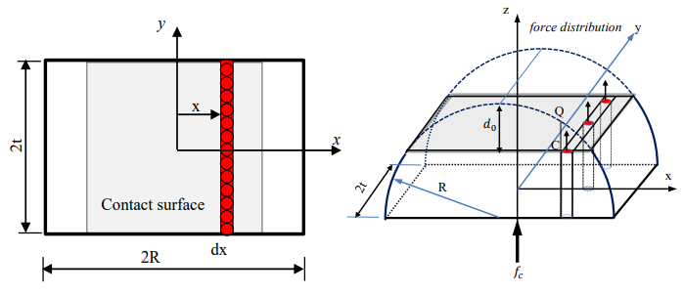

**Difficulty**

1. To work out the equivalent impact force, we have to know the velocity before impact, how to identify the moment to ensure the accuracy should be a problem.
2. The distributed force is estimated under the circumstance that the combined force is just in one direction which is slightly different from our scenario, so I’m still trying to make it applicable to our project.

**Plan**

1. I still need to look up more cases for multi-contact problem, especially for irregular deformation;
2. The estimation method for modelling multi-contact distribution force seems not 100 percent applicable for our project, I will read that paper again to find if I could make some amendments and assumptions so that it can be used in our model.